**PROJECT REPORT**

“Employee Management System”



**Guided By: Submitted By:**

Mr. Shilpa Mam Rishabh Kumar

Enrolment No: 166764004

**TITLE OF THE PROJECT**

“Employee Management System”

**PROJECT CATEGORY**

“Employee Management System” is an Enterprise Resource Planning. It is a web based application. It can be accessed using a browser e.g. Chrome and Internet Explorer etc.

**Guided By: Submitted By:**

Mr. Arshad Iqbal Rishabh Kumar

Enrollment No : 166764004

**Abstract**

**Employee Management System** is a Web application, developed to maintain the details of employees working in any organization. It maintains the information about the personal details of their employees . The application is actually a suite of applications developed using Java.

It is simple to understand and can be used by anyone who is not even familiar with simple employees system. It is user friendly and just asks the user to follow step by step operations by giving him few options. It is fast and can perform many operations of a company.

This Web Application has been developed using the powerful coding tools of JAVA at Front End and MySql Database Server at Back End. The Web Application is very user friendly. The Web Application contains different modules like Employee details. This version of the s Application has multi-user approach. For further enhancement or development of the apploication user’s feedback will be considered.

**Acknowledgement**

I express my Gratitude to Mr. Arshad Iqbal for his help, guidance throughout the work for this project without which I would not have been able to complete this project to such a success.

I would also like to thank my classmates who helped me directly or indirectly in accomplishing this work

Finally I would also like to thank other faculty members who provided me with Moral support during the course of this project.

**Index**

* Introduction 5
* Objectives 6
* Project Category 7
* Analysis
  + - E-R Diagram 8
    - Modules 9
    - DFD (Data Flow Diagram) 10
    - Tools and Platform Used 12
* Database Design 13
* Class Diagram 14
* Case Tool Diagram 15
* Activity Flow Diagram 16
* Input and Output Screens 18
* Requirement 27
* Hardware and Software Used 28
* Project Code 30
* Bibliography 74
* Testing 75
* Future Scope and Enhancement and Report Generation 75

**Introduction**

Employee Management system is a web application of a company that enables users to create and store Employee Records. This web application is helpful to department of the organization which maintains data of employees related to an organization.

The purpose of Employee Management System is to automate the existing manual system by the help of computerized equipments and full-fledge computer software, fulfilling their requirements, so that valuable data or information can be stored for a longer period with easy accessing and manipulation of the same. The required software and hardware are easily available and easy to work with.

The Employee Management System has been developed to override the problems prevailing in the practicing manual system. This web application is supported to eliminate and in some cases reduce the hardship faced by the existing system.

Moreover this system is designed for the particular need of the company to carry out operation in a smooth and effective manner.

This web application is reduced as much as possible to avoid errors while entering the data. It is also provides error message while entering invalid data. No formal knowledge is needed for the guest this system. Thus by this all it provides it is user friendly.

**Objective**

This project is aimed at developing Employee Management System that allows automating or computerizing all employee management operations.

The main objective is to manage the details of employee, salary, leaves, and dependent etc. It manages all the information about employee, skill, registration.

The project is totally built at administrative and thus only the administrator guaranteed the access. The purpose of the project is to build a web application program to reduce the manual work for managing the employee details.

* To manage the key activities available for resources like applying leave, add dependent details, see the project details etc.
* It will help to reduce the data redundancy, data loss.

**Project Category**

ERP Stands for "Enterprises Resource Planning."

ERP is Business Management Application. It is a suite of integrated application that helps users to store and manage data of their business.

One of the most important activities associated with the implementation of an ERP system is the opportunity to streamline and improve the business operations of an organization through business process re-engineering and the by implementing the best practices and standards.

An ERP system is easily scalable so adding new functionality according to the business plan is very easy.

It helps to helps make reporting easier and more customizable.

* **Front End**
* HTML, CSS, JavaScript, JSP, Servelt
* **Back End**
* MYSQL, JDBC.

**E.R. Diagram**

N

1

Works_for

Works_on

Department

Employee

Has

Manages

Project

1

1

N

M

Dependent

**Modules of Employee Management System**

* **Employee**
* The system must allow an employee to login & logout.
* The system must allow an employee to see details of project(s) s/he working on.
* The system must allow an employee to request for leaves.
* The system must allow an employee to check his/her salary.
* The system must allow an employee to view their dependent.
* **Admin**
* The system must allow an admin to login & logout.
* The system must allow an admin to add, modify and delete (inactive) the detail of an employee.
* The system must notify an admin to about the leave request.
* The system must allow an admin to approve or reject an employee request.
* The system must allow an admin to add, view, an edit project detail.
* The system must allow an admin to generate the project report.
* **Salary**
* The system must allow an admin to calculate salary.
* **Report**
* It generates of the project report of an employee, salary, skills.
* Provide filter reports on leaves etc.

**DFD (Data Flow Diagram).**

**Zero Level DFD**

Add Project,update employee detail, calculate salary

Project details , salary details

View project,

salary detail

Admin

Employee

Acknowledgement

**.**

**First Level DFD**

Empid,pass

Employee DB

Empid,pass

Ack

Proid

Pro detail

Project DB

Employee

Pro detail

Check salary

Salary

Salary

Salary DB

userid,pass

Admin DB

Userid ,pass

Pro detail

Ack

Project DB

Ack

Proid,title,head, emp working

Salary

Salary DB

Admin

Ack

**Second Level DFD**

Pro detail

Salary

userid,pass

Pro detail

Report DB

Employee DB

Project DB

Admin DB

Proid,title,head, emp working

Ack

Userid ,pass

Ack

Admin

Ack

**Tools And Platform Used**

* **Front End**
* HTML, CSS, JavaScript, JSP, Servelt .
* **Back End**
* MYSQL, JDBC.

**Databases Design**

**Employee**

|  |  |  |  |  |  |  |
| --- | --- | --- | --- | --- | --- | --- |
| Emp_Id | First Name | Last Name | E-maill | Password | Gender | DeptID |

**Salary**

|  |  |  |  |  |  |  |
| --- | --- | --- | --- | --- | --- | --- |
| EmpID | Basic Salary | HRA | DA | TA | Tax | Net Salary |

**Department**

**Department**

|  |  |  |
| --- | --- | --- |
| Dept_Id | Name | Manager |

**Project**

|  |  |  |
| --- | --- | --- |
| Pro_Id | Title | Head |

**Dependent**

|  |  |  |  |  |
| --- | --- | --- | --- | --- |
| Emp_Id | Name | Age | Gender | D.O.B |

**Works On**

|  |  |  |  |
| --- | --- | --- | --- |
| Pro_Id | Emp_Id | Start Date | No of Hours |

|  |  |  |  |  |  |
| --- | --- | --- | --- | --- | --- |
| Emp_Id | Date | Reason | No.of Days | Staus(app/rej) | Note |

**Leave Record**

**Admin**

|  |  |  |
| --- | --- | --- |
| User Name | Password | Last Access |

**Class Diagram**

|  |
| --- |
| **Employee** |
| -name: String  -gender: char  -id:integer  -phone: String  -salary: Salary |
| +getName():String  +setName(String)  +getGender(): char  +setGender(char)  +getId():integer  +setId(integer)  +getPhone():String  +setPhone(String)  +getSalary:long  +setSalary(long) |

|  |
| --- |
| **Dependent** |
| -name: String  -age: integer  -dob: date  -gender: char |
| +getName():String  +setName(String)  +getAge():integer  +setAge(integer)  +getDob():date  +setDob(date)  +getGender():char  +setGender(char) |

|  |
| --- |
| **Project** |
| -id: integer  -title: String  -head:String |
| +getId():integer  +setId(integer)  +getTitle():String  +setTitle(String)  +getHead(): |
| **Salary** | |
| -basic: integer  -hra: float  -ta:float  -tax:float  -total: double | |
| +getBasic():integer  +setBasic(integer)  +setTotalSalary(double)  +getTotalSalary():double | |

|  |
| --- |
| **Department** |
| -name: String  -id:integer  -address: String |
| +getName():String  +setName(String)  +getId():integer  +setId(integer)  +getAdd():String  +setAdd(String) |

|  |
| --- |
| **Admin** |
| -adminId:String  -adminPass:String |
| +getId():String  +setId(String)  +getPass():String  +setPass(String) |

**Case Tool Diagram**

|  |
| --- |
|  |

**Employee**

|  |
| --- |
|  |

**Admin**

**Activity Flow Diagram**

Start

No

valid

Yes

Stop

**EMPLOYEE**

**ADMIN**

**GUEST**

Start

No

valid

Yes

Valid Reason

Update

No

Yes

Stop

**Input And Output Screens**

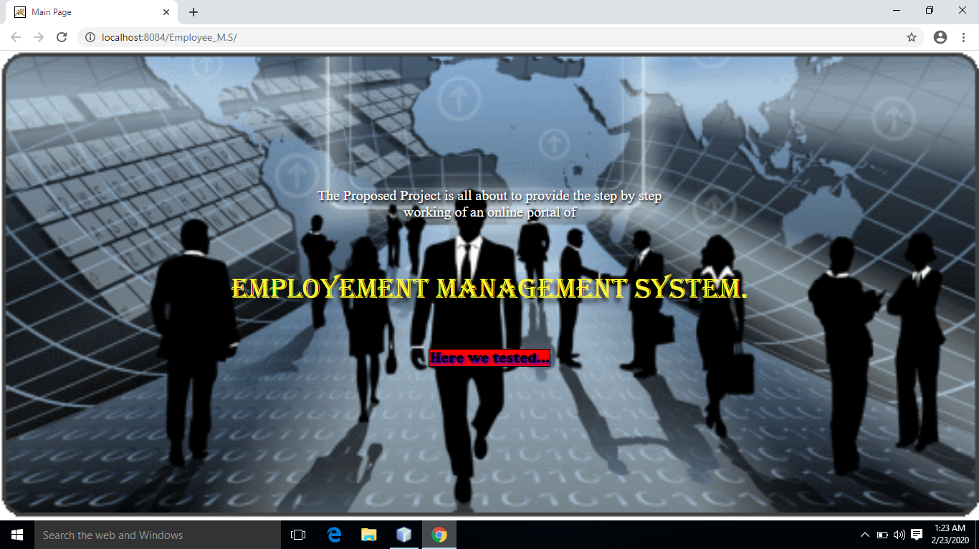

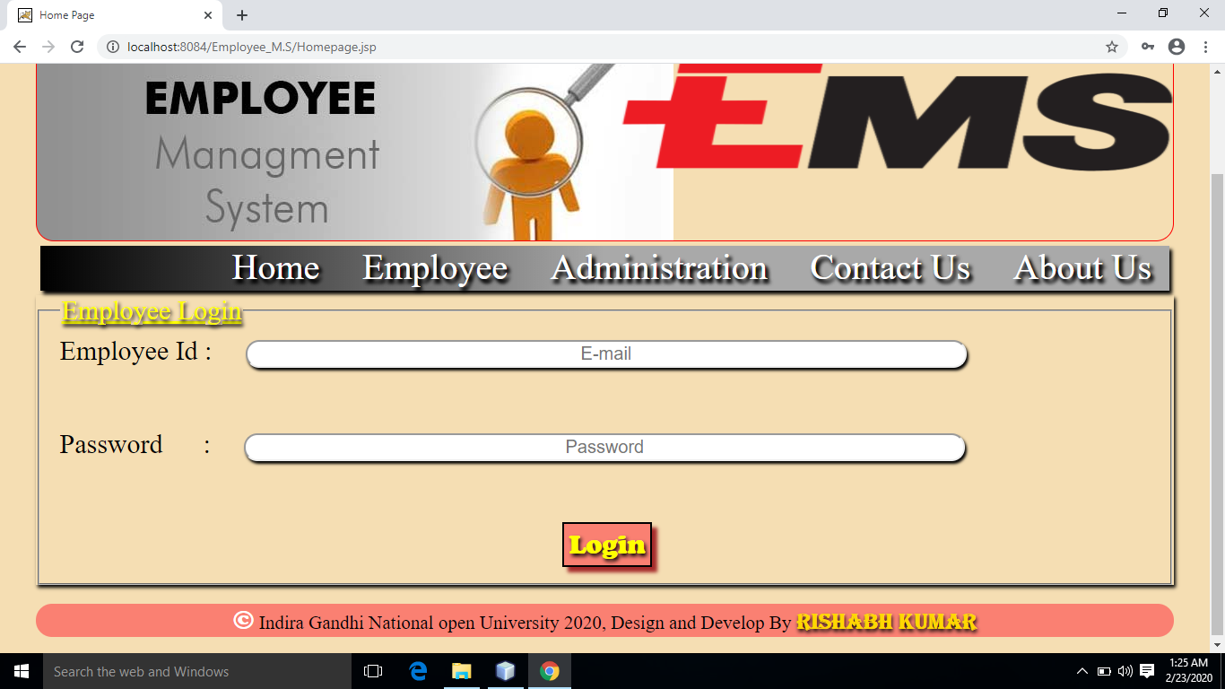

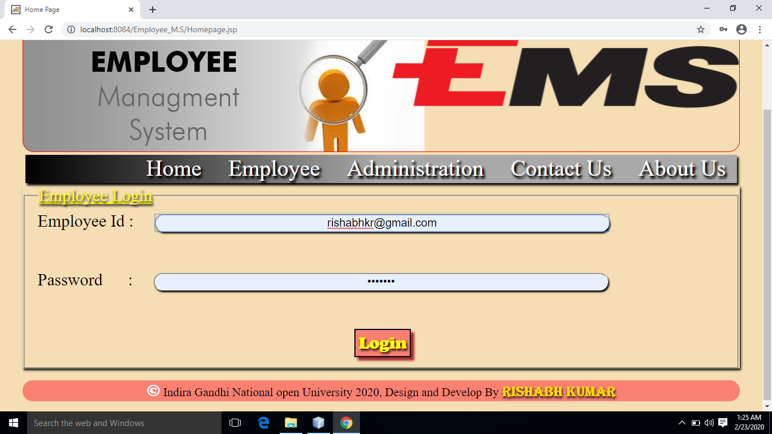

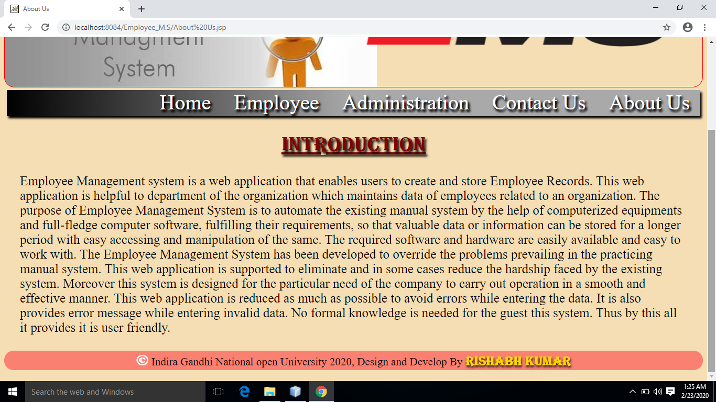

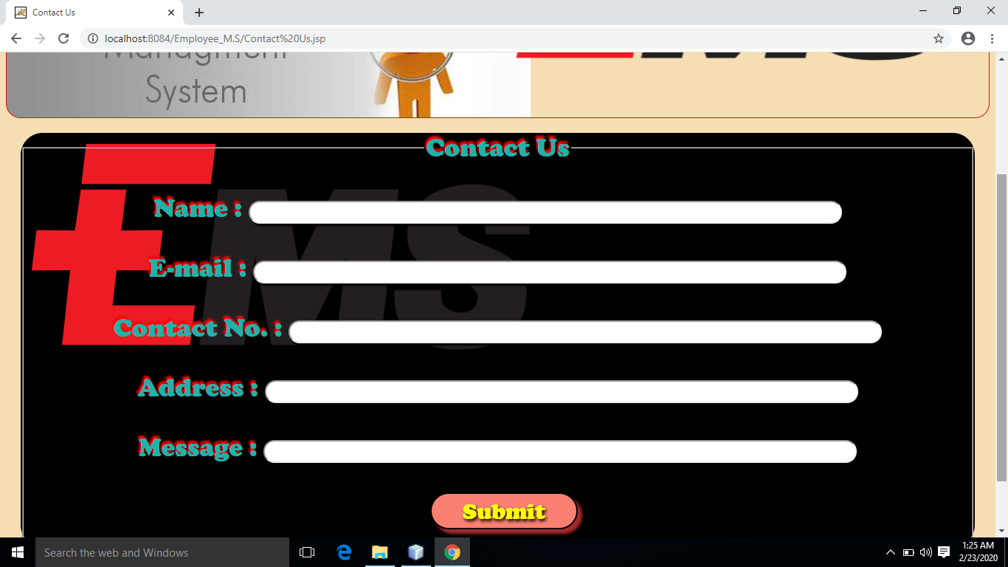

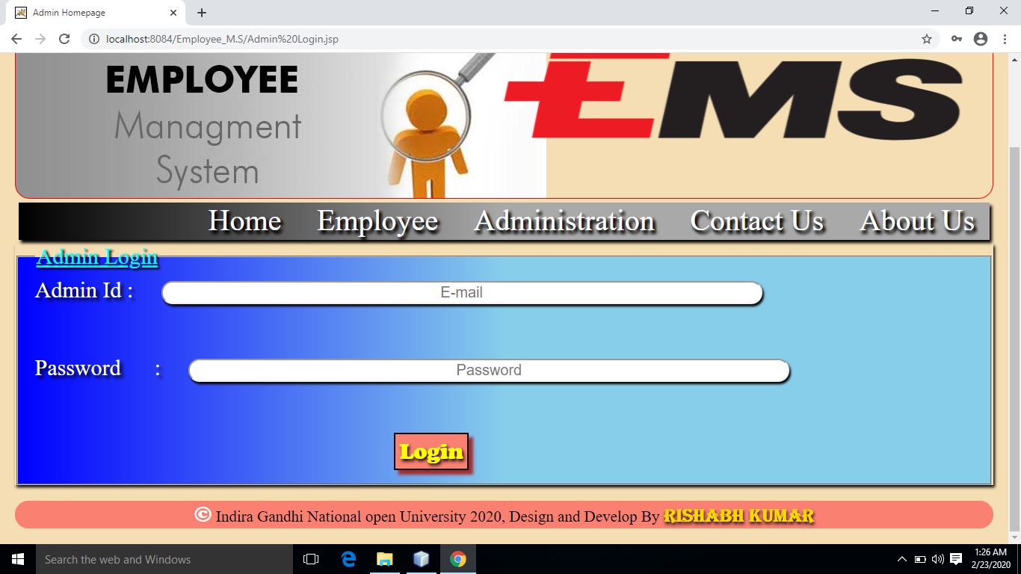

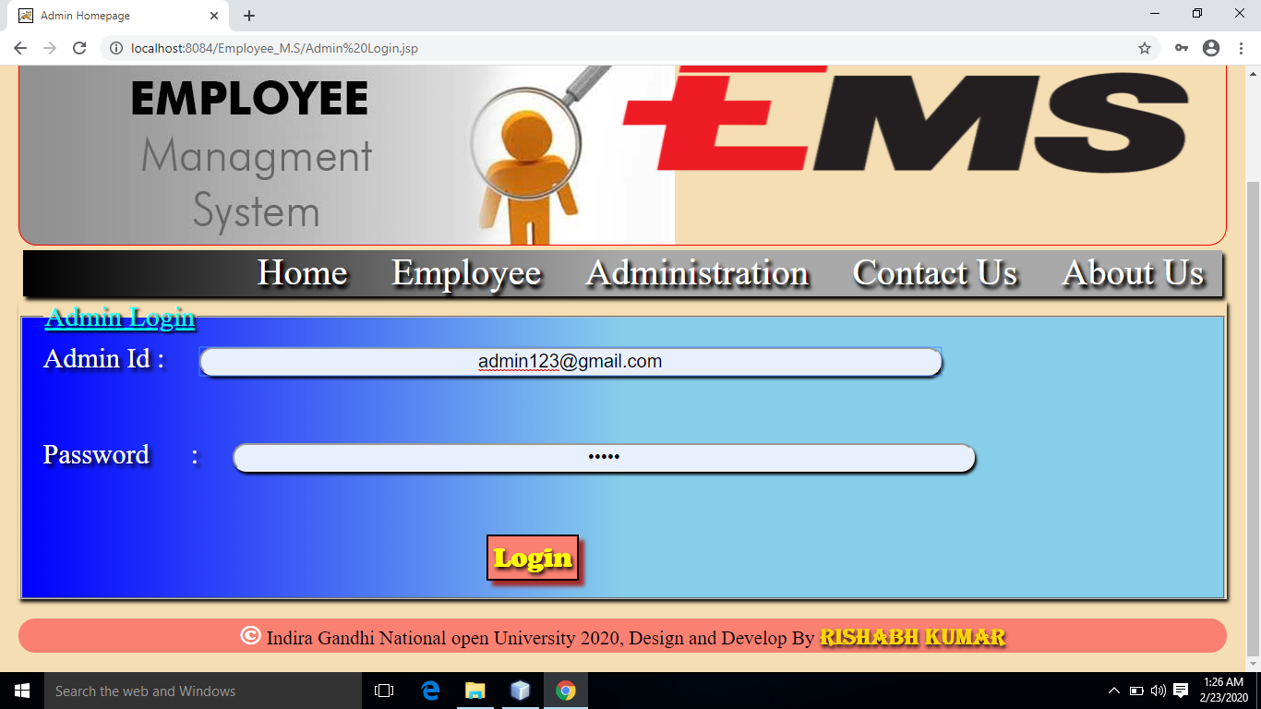

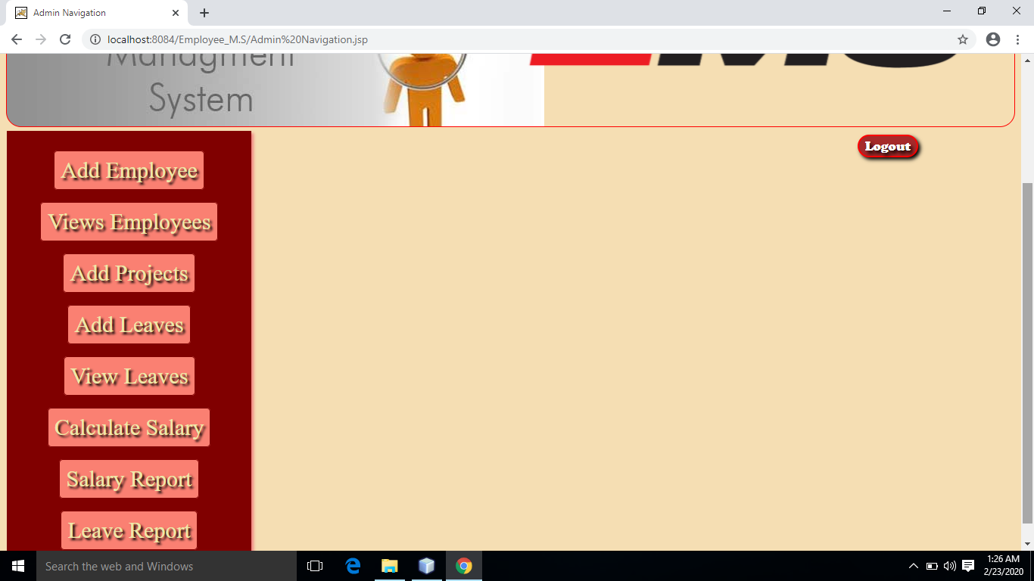

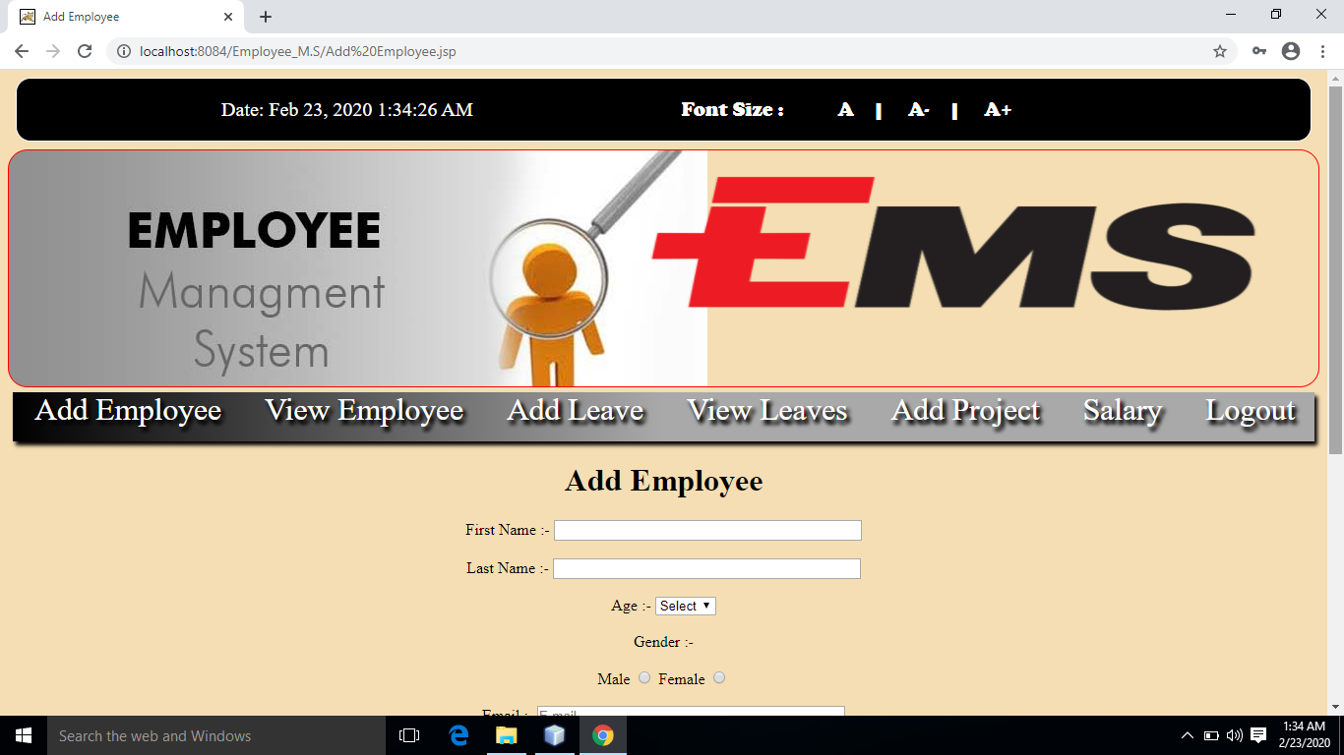

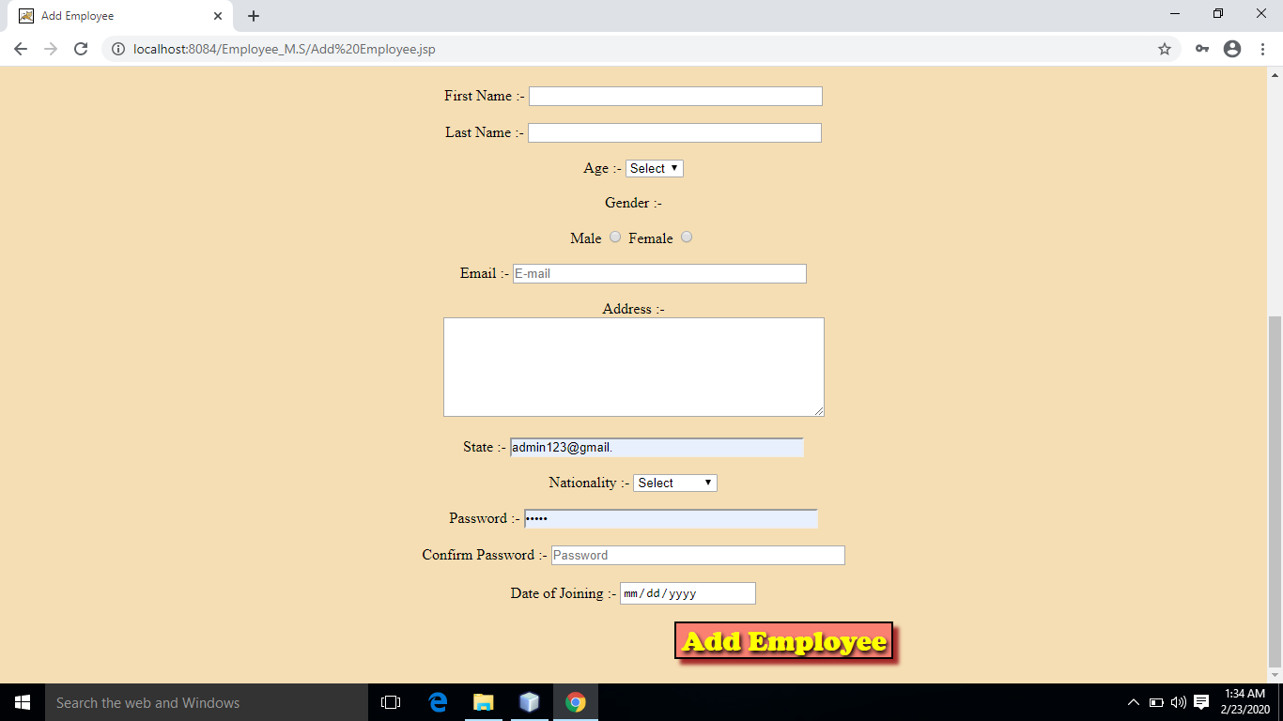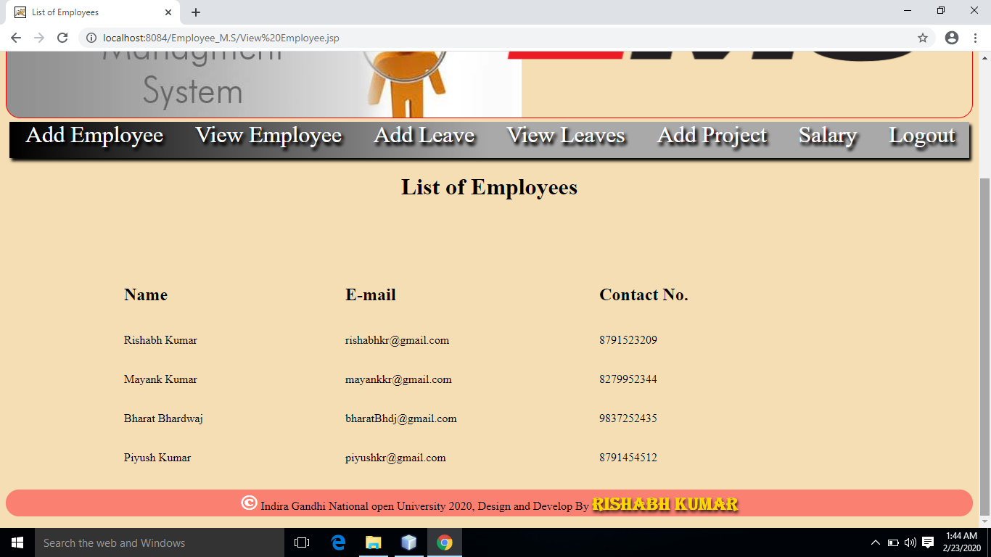

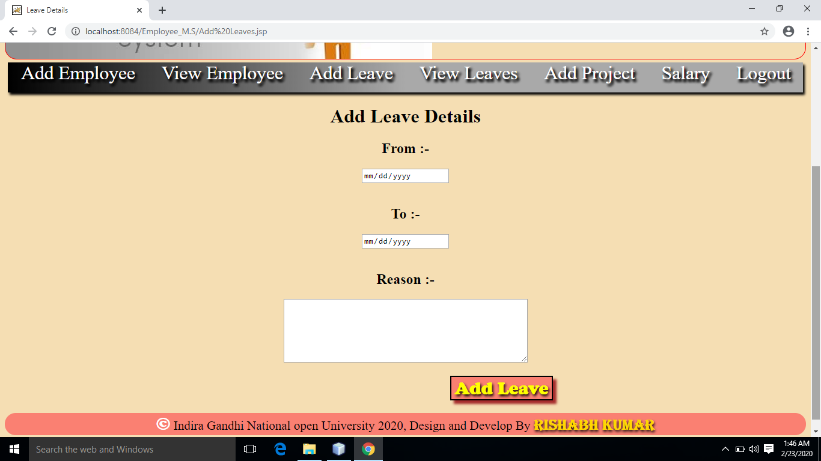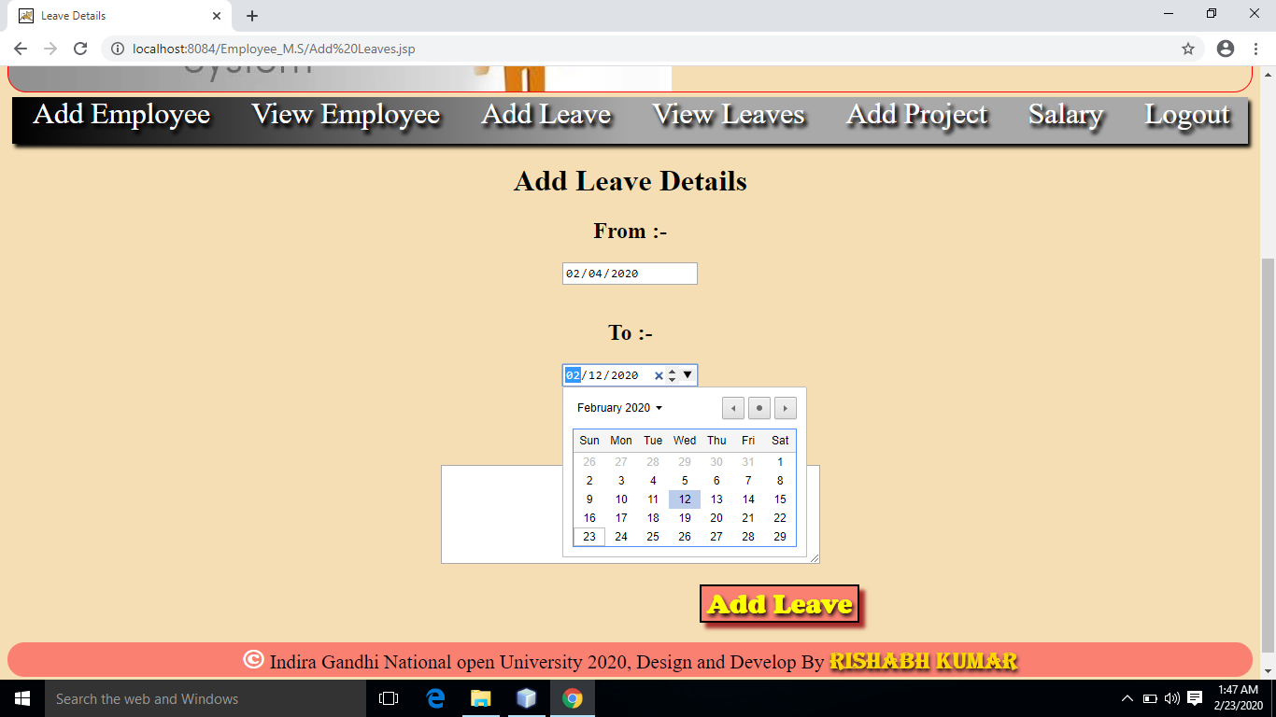

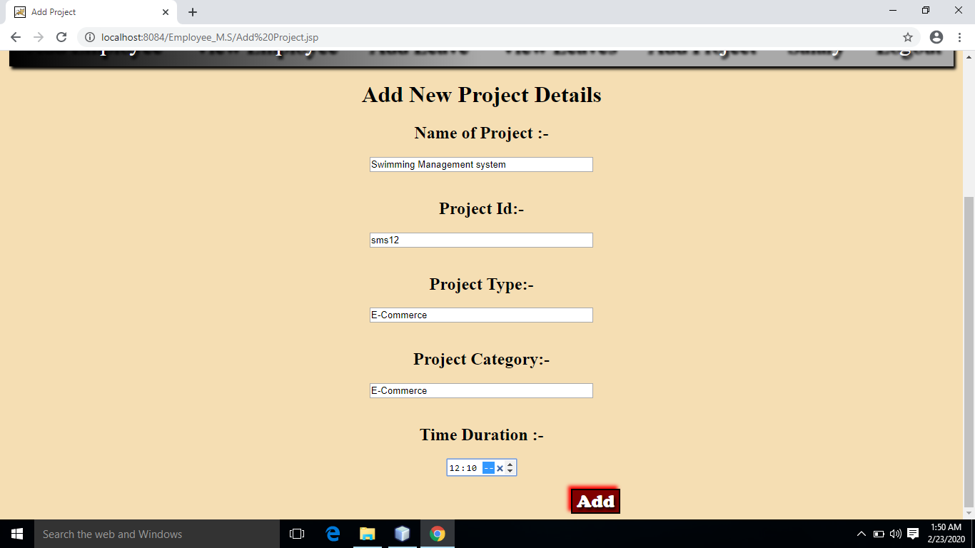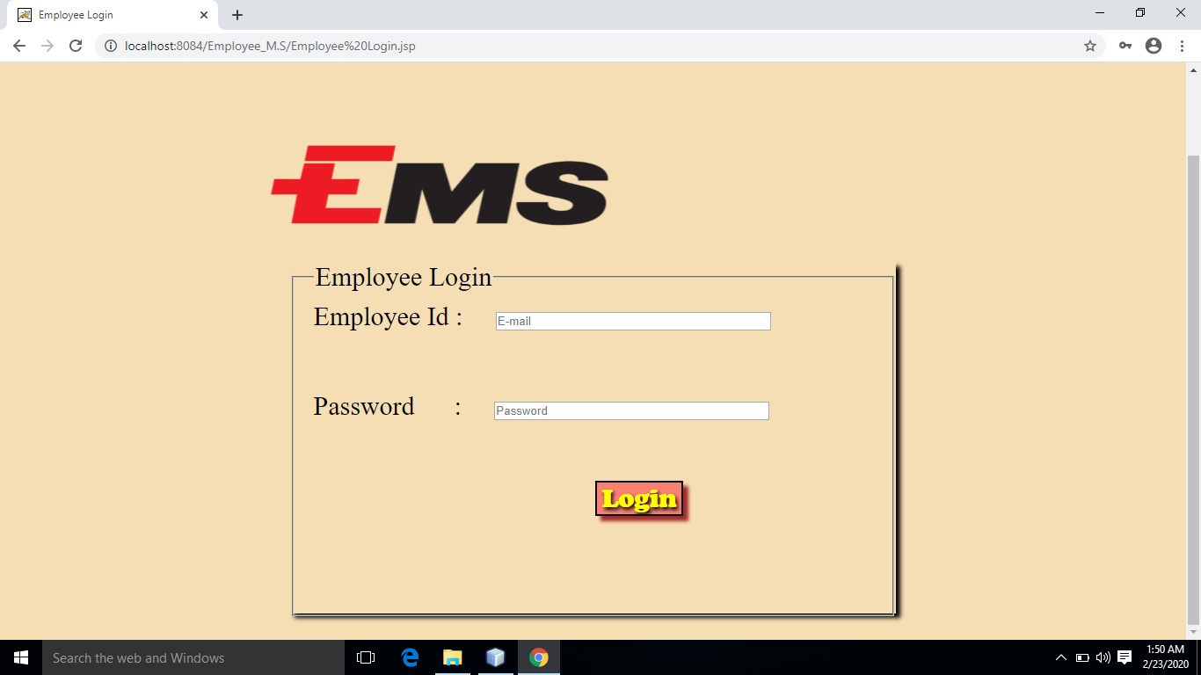

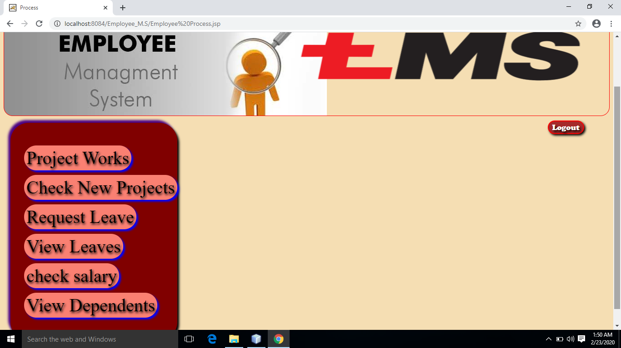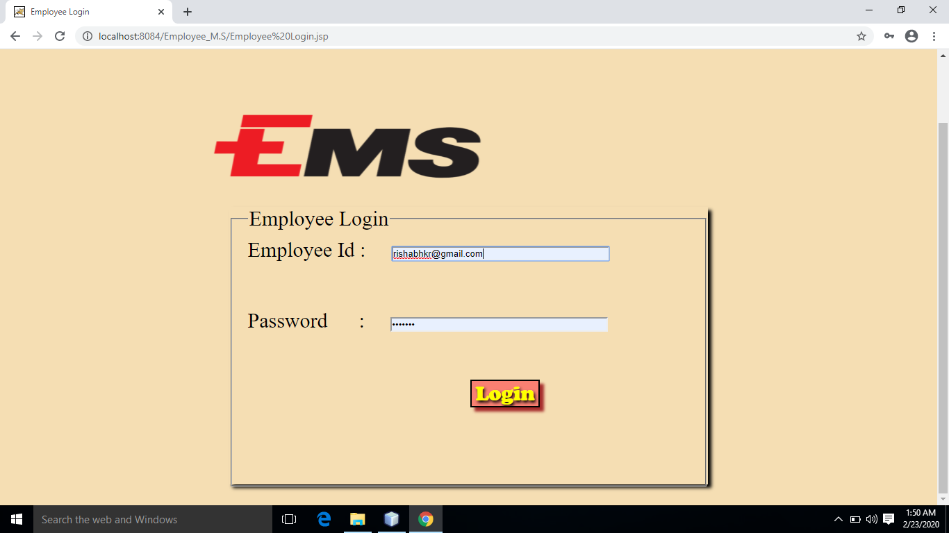

**Requirements**

* **Hardware Requirements Specification**
* **Processor :** Intel Pentium processor 500 MHz or faster.
* **Speed :** 2.4GHz
* **Ram :** Minimum 2 GB.
* **H.D.D :** Minimum 40GB or above.
* **Software Requirements Specification**
* **Operating System :**  Window 10
* **IDE**  **:** Net beans.
* **Web Browser’s :**  Google chrome.
* **Server :** Apache Tomcat,Glassfish

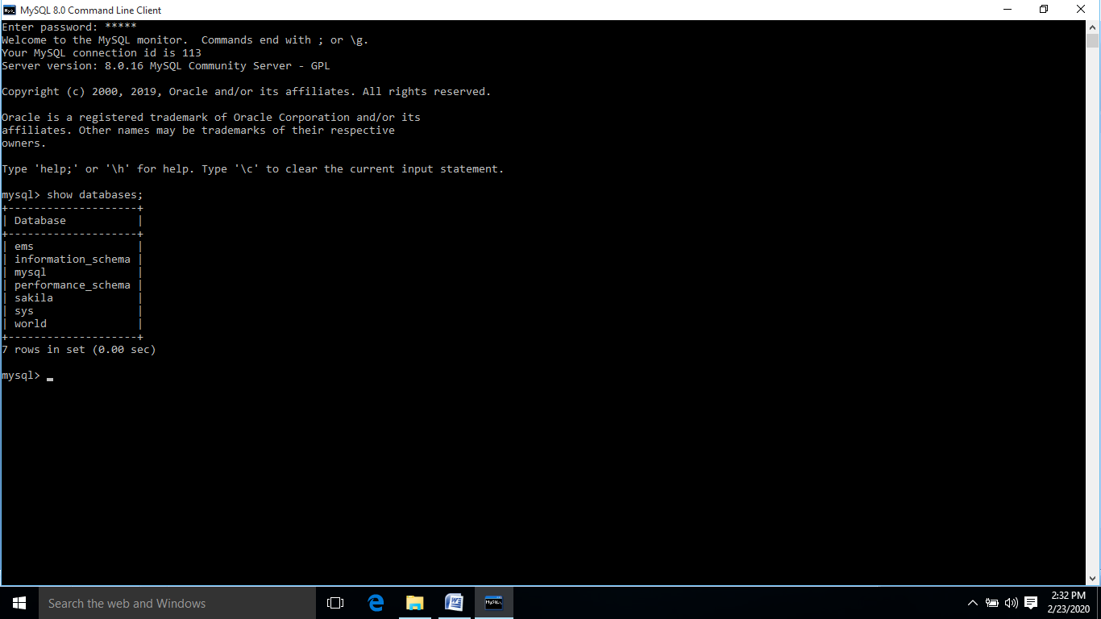

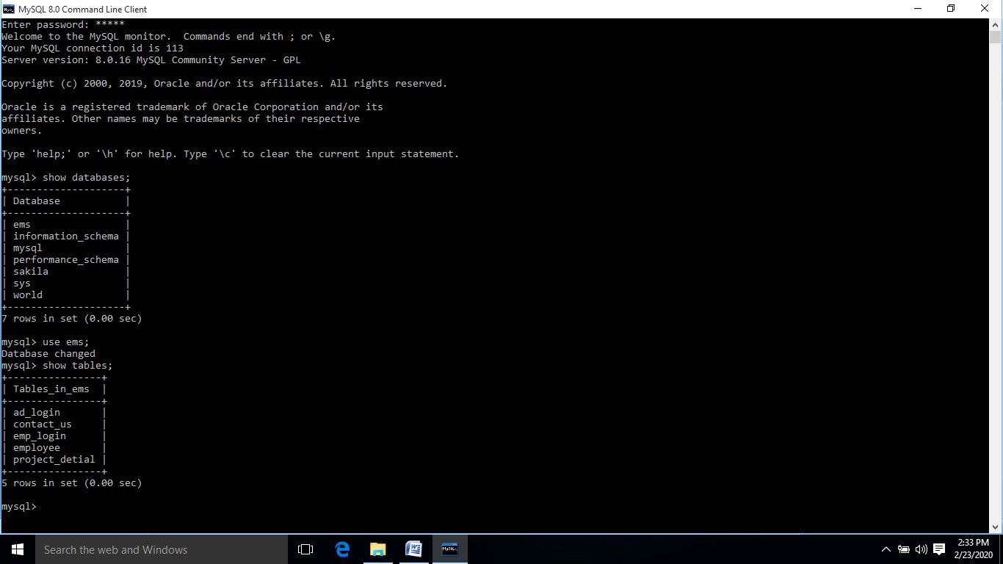

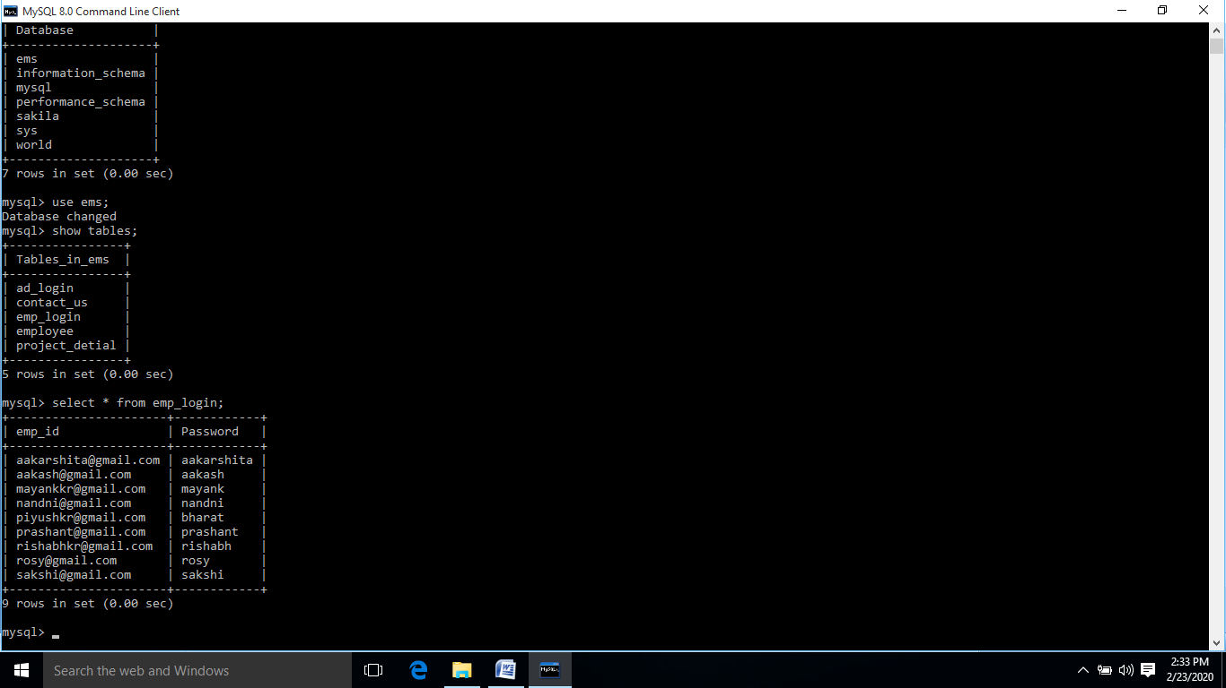

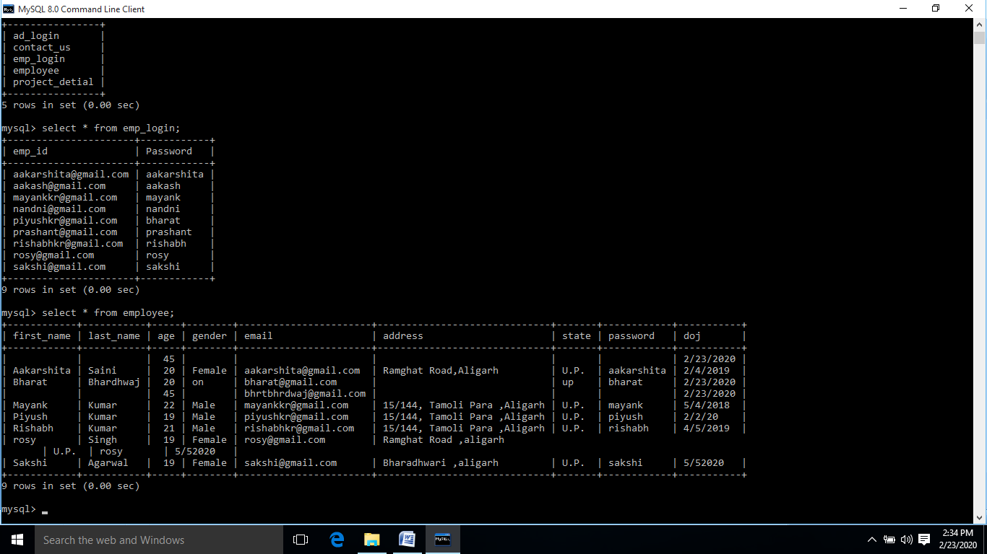

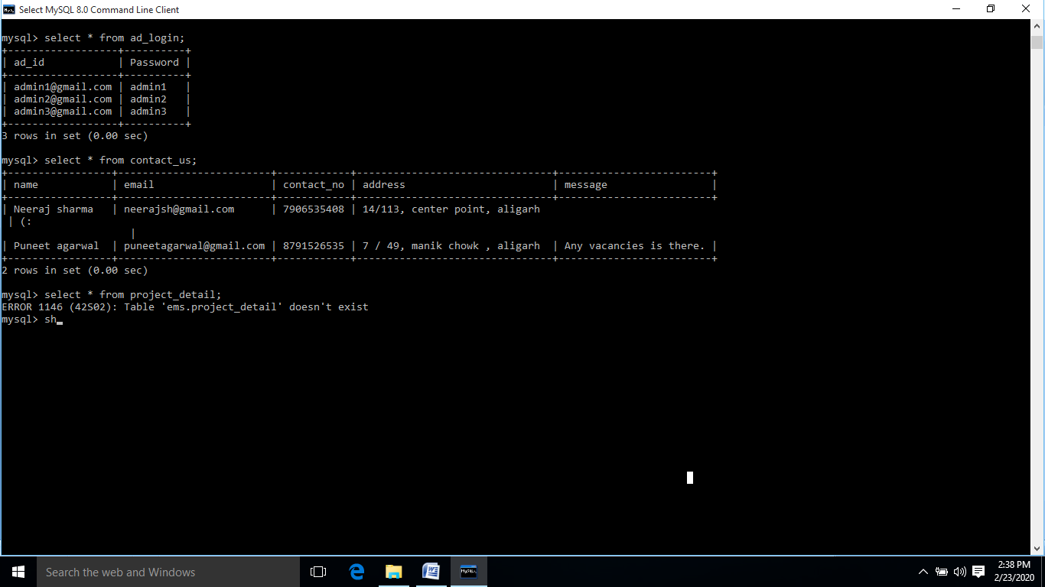

**Project Code**

**Index.html**

<!DOCTYPE html>

<html>

<head>

<title>Main Page</title>

<meta charset="UTF-8">

<link rel="stylesheet" href="Mainpage.css" type="text/css"/>

</head>

<body>

<div class="Info">

<p>The Proposed Project is all about to provide the step by step <br/>working of an online portal of <br/><br/><br/><br/><span id="Main">Employement Management System.</span></p>

</div>

<div class="Test">

<br/><br/><a href="Homepage.jsp">Here we tested...</a>

</div>

</body>

</html>

**Mainpage.css**

body{

background-image: url('Mainpage.png');

position: relative;

background-repeat: no-repeat;

background-size: auto;

background-size: cover;

margin: 14%;

}

a{

color: black;

background: red;

border: 1px solid black;

text-align: center;

display: inline-block;

text-decoration: none;

font-size: 20px;

font-family: cooper;

text-shadow: 2px 2px 4px blue;

margin: 2px;

}

p{

color: white;

text-shadow: 1px 2px 3px black;

font-size: 20px;

}

.Info{

text-align: center;

}

#Main{

font-family: algerian;

font-size: 20px;

color: #fff531;

text-shadow: -2px 6px 7px black;

font-size: 40px;

}

#Main:hover{

font-size: 45px;

color: white;

text-shadow: 4px 3px 3px blue,-4px -3px 3px black;

}

.Test{

text-align: center;

}

a:hover{

color: white;

background: black;

font-size: 30px;

border: 1px solid white;

border-radius: 10px;

}

.style{

background: black;

color: white;

border: solid 1px white;

border-radius: 15px;

margin: 8px;

}

.Date{

text-align: left;

font-size: 20px;

}

.Screen{

text-align: right;

font-family: cooper;

font-size: 20px;

}

.Date,.Screen{

display: inline-block;

margin-left: 13pc;

}

a:hover{

color: red;

text-decoration: underline;

}

**Header.jsp**

<%@page contentType="text/html" pageEncoding="UTF-8"%>

<!DOCTYPE html>

<html>

<head>

<meta http-equiv="Content-Type" content="text/html; charset=UTF-8">

<title>Header</title>

<style>

.Logo{

background-color: white;

margin-left: 40pc;

background-color: wheat;

}

img{

margin: 20px;

margin-left: 0px;

height: 150px;

width: 40pc;

}

.Header{

background-image: url("Logo1.png");

background-repeat: no-repeat;

border: 1px solid red;

border-radius: 20px;

height: 240px;

}

</style>

</head>

<body>

<div class="Header">

<div class="Logo">

<img src="Logo3.png" height="100px" align="left" width="200px" />

</div><br/><br/><br/><br/><br/><br/><br/>

</div>

</body>

</html>

**Navigation.jsp**

<%@page contentType="text/html" pageEncoding="UTF-8"%>

<!DOCTYPE html>

<html>

<head>

<title>Navigation</title>

<style>

.Nav{

background: linear-gradient(to right,black,darkgray,darkgray);

height: 50px;

text-align:right;

margin: 5px;

box-shadow: 3px 4px 4px black;

}

a{

margin: 20px;

text-decoration: none;

color: white;

text-shadow: 3px 4px 4px black,3px 4px 4px black;

font-size: 40px;

}

a:hover{

color: white;

text-shadow: 3px 4px 4px black,3px 4px 4px black;

text-decoration: underline;

box-shadow: 2px 4px 3px black;

background-color: salmon;

}

</style>

</head>

<body>

<div class="Nav">

<a href="Homepage.jsp">Home</a>

<a href="Employee Login.jsp">Employee</a>

<a href="Admin Login.jsp">Administration</a>

<a href="Contact Us.jsp">Contact Us</a>

<a href="About Us.jsp">About Us</a>

</div>

</body>

</html>

**Footer.jsp**

<%@page contentType="text/html" pageEncoding="UTF-8"%>

<!DOCTYPE html>

<html>

<head>

<title>Footer</title>

<style>

.Footer{

background: salmon;

border-radius: 10pc;

font-size: 21px;

text-align: center;

}

#Main1{

color: white;

font-family: cooper;

font-size: 30px;

}

#Main1:hover{

color: darkblue;

}

#Main2{

color: gold;

text-shadow: 1px 3px 4px black;

font-size: 25px;

font-family: algerian;

}

#Main2:hover{

font-size: 30px;

color: cyan;

}

</style>

</head>

<body>

<div class="Footer">

<p><span id="Main1"><b>&copy</b></span> Indira Gandhi National open University 2020, Design and Develop By <span id="Main2"><b>Rishabh Kumar</b></span></p>

</div>

</body>

</html>

**Style.css**

body{

background-color: wheat;

}

input[type=submit]{

background-color: salmon;

font-size: 30px;

font-family: cooper;

color: yellow;

text-shadow: 2px 3px 4px black;

border: 1.8px solid black;

margin-left: 20pc;

box-shadow: 6px 6px 4px brown;

}

input[type=submit]:hover{

background-color: maroon;

color: white;

box-shadow: -4px -4px 5px red;

font-size: 25px;

}

**Homepage.jsp**

<%@page contentType="text/html" pageEncoding="UTF-8"%>

<!DOCTYPE html>

<html>

<head>

<meta http-equiv="Content-Type" content="text/html; charset=UTF-8">

<title>Home Page</title>

<link rel="stylesheet" href="Style.css" type="text/css" /> <!--external stylesheet -->

<style>

body{

border-shadow: 5px 6px 1px black;

font-size: 30px;

margin: 20px;

}

.Login{

box-shadow: 2px 3px 4px black;

}

input[type=text],[type=password]{

height: 25px;

width: 50pc;

box-shadow: 2px 3px 3px black;

border-radius: 20px;

font-size: 20px;

text-align: center;

}

#heading{

text-decoration: underline;

text-shadow: 2px 3px 4px black;

color: yellow;

text-border: 2px solid black;

}

input[type=submit]{

background-color: salmon;

height: 50px;

width: 100px;

font-size: 30px;

font-family: cooper;

color: yellow;

text-shadow: 2px 3px 4px black;

border: 1.8px solid black;

margin-left: 35pc;

box-shadow: 6px 6px 4px brown;

}

input[type=submit]:hover{

background-color: maroon;

color: white;

box-shadow: -4px -4px 5px red;

font-size: 25px;

}

.Main{

margin: 20px;

}

</style>

</head>

<body>

<div class="Main">

<%@include file="Font Size.jsp" %>

<%@include file="Header.jsp" %>

<%@include file="Navigation.jsp" %>

<div class="Login">

<fieldset>

<legend><span id="heading">Employee Login</span></legend>

<form action="Employee Process.jsp" method="post">

Employee Id : &nbsp&nbsp&nbsp

<input type="text" name="EmpId" placeholder="E-mail" maxlength="25" required="true"><br/><br/><br/>

Password &nbsp&nbsp&nbsp&nbsp&nbsp: &nbsp&nbsp&nbsp

<input type="password" name="Pass" placeholder="Password" maxlength="8" required="true"><br/><br/><br/>

<input type="submit" value="Login">

</form>

</fieldset>

</div>

<%@include file="Footer.jsp" %>

</div>

</body>

</html>

**About us.jsp**

<%@page contentType="text/html" pageEncoding="UTF-8"%>

<!DOCTYPE html>

<html>

<head>

<meta http-equiv="Content-Type" content="text/html; charset=UTF-8">

<title>About Us</title>

<link rel="stylesheet" href="Style.css" type="text/css" />

</head>

<body>

<%@include file="Font Size.jsp"%>

<%@include file="Header.jsp" %>

<%@include file="Navigation.jsp"%>

<div class="Container">

<h1 style="font-size: 40px; text-align: center; font-family: algerian;color: maroon;text-shadow: 3px 4px 4px black;text-decoration: underline;">Introduction</h1>

<p style="font-size: 25px;margin: 30px">

Employee Management system is a web application that enables users to create and store Employee Records. This web application is helpful to department of the organization which maintains data of employees related to an organization.

The purpose of Employee Management System is to automate the existing manual system by the help of computerized equipments and full-fledge computer software, fulfilling their requirements, so that valuable data or information can be stored for a longer period with easy accessing and manipulation of the same. The required software and hardware are easily available and easy to work with.

The Employee Management System has been developed to override the problems prevailing in the practicing manual system. This web application is supported to eliminate and in some cases reduce the hardship faced by the existing system.

Moreover this system is designed for the particular need of the company to carry out operation in a smooth and effective manner.

This web application is reduced as much as possible to avoid errors while entering the data. It is also provides error message while entering invalid data. No formal knowledge is needed for the guest this system. Thus by this all it provides it is user friendly.

</p>

</div>

<%@include file="Footer.jsp"%>

</body>

</html>

**Contact Us.jsp**

<%@page contentType="text/html" pageEncoding="UTF-8"%>

<!DOCTYPE html>

<html>

<head>

<meta http-equiv="Content-Type" content="text/html; charset=UTF-8">

<title>Contact Us</title>

<link rel="stylesheet" href="Style.css" type="text/css" />

<style>

.Container{

background-color: #000;

color: lightseagreen;

text-shadow: -2px -4px 3px red;

background-image: url('Logo3.png');

background-repeat: no-repeat;

font-family: cooper;

margin: 20px;

inline-box-align: last;

border-radius: 30px;

font-size: 35px;

}

input[type=text],[type=email]{

height: 25px;

width: 50pc;

box-shadow: 2px 3px 3px black;

border-radius: 20px;

font-size: 20px;

text-align: center;

}

input[type=submit]{

background-color: salmon;

height: 50px;

width: 200px;

font-size: 30px;

font-family: cooper;

color: yellow;

text-shadow: 2px 3px 4px black;

border: 1.8px solid black;

margin-left: 1pc;

box-shadow: 6px 6px 4px brown;

border-radius: 30px;

}

input[type=submit]:hover{

background-color: maroon;

color: white;

box-shadow: -4px -4px 5px red;

font-size: 25px;

}

fieldset{

text-align: center;

}

form{

margin-top: 30px;

}

</style>

</head>

<body>

<%@include file="Font Size.jsp" %>

<%@include file="Header.jsp" %>

<div class="Container">

<fieldset>

<legend>Contact Us </legend>

<form action=" " method="post">

Name : <input type="text" name="C_name" required="true"/><br/><br/>

E-mail : <input type="email" name="C_mail" maxlength="25" required="true" /><br/><br/>

Contact No. : <input type="text" name="C_contact" maxlength="10" required="true"/><br/><br/>

Address : <input type="text" name="C_address" required="true"/><br/><br/>

Message : <input type="text" name="C_reason" required="true"/><br/><br/>

<input type="submit" value="Submit"/>

</form>

</fieldset>

</div>

<%@include file="Footer.jsp" %>

</body>

</html>

**Admin.jsp**

<%@page contentType="text/html" pageEncoding="UTF-8"%>

<!DOCTYPE html>

<html>

<head>

<meta http-equiv="Content-Type" content="text/html; charset=UTF-8">

<title>Admin Homepage</title>

<link rel="stylesheet" href="Style.css" type="text/css" />

<style>

body{

border-shadow: 5px 6px 1px black;

font-size: 30px;

margin: 20px;

}

.Login{

box-shadow: 2px 3px 4px black;

}

input[type=text],[type=password]{

height: 25px;

width: 50pc;

box-shadow: 2px 3px 3px black;

border-radius: 20px;

font-size: 20px;

text-align: center;

}

#heading{

text-decoration: underline;

text-shadow: 2px 3px 4px black;

color: cyan;

text-shadow: 3px 2px 3px black;

text-border: 2px solid black;

}

input[type=submit]{

background-color: salmon;

height: 50px;

width: 100px;

font-size: 30px;

font-family: cooper;

color: yellow;

text-shadow: 2px 3px 4px black;

border: 1.8px solid black;

margin-left: 30pc;

box-shadow: 6px 6px 4px brown;

}

input[type=submit]:hover{

background-color: maroon;

color: white;

box-shadow: -4px -4px 5px red;

font-size: 25px;

}

.Main{

margin: 20px;

}

fieldset{

background: linear-gradient(to left,skyblue,skyblue,blue);

color: white;

text-shadow: 4px 4px 4px black;

}

</style>

</head>

<body>

<%@include file="Font Size.jsp" %>

<%@include file="Header.jsp" %>

<%@include file="Navigation.jsp" %>

<div class="Login">

<fieldset>

<legend><span id="heading">Admin Login</span></legend>

<form action="Admin Navigation.jsp" method="post">

Admin Id : &nbsp&nbsp&nbsp

<input type="text" name="adminId" placeholder="E-mail" maxlength="25" required="true"><br/><br/><br/>

Password &nbsp&nbsp&nbsp&nbsp&nbsp: &nbsp&nbsp&nbsp

<input type="password" name="Pass" placeholder="Password" maxlength="8" required="true"><br/><br/><br/>

<input type="submit" value="Login">

</form>

</fieldset>

</div>

<%@include file="Footer.jsp" %>

</body>

</html>

**Font Size.jsp**

<%@page contentType="text/html" pageEncoding="UTF-8"%>

<!DOCTYPE html>

<html>

<head>

<meta http-equiv="Content-Type" content="text/html; charset=UTF-8">

<title>Font Body</title>

<script type="text/javascript">

function ZoomPage(Param){

var width;

if(Param=='A'){

width= screen.width;

document.getElementById(Param).className=" fontfocus";

document.getElementById('A+').className="fontnormal";

document.getElementById('A-').className="fontnormal";

}

else if(Param=='A+'){

width= screen.width-50;

document.getElementById(Param).className="fontfocus";

document.getElementById('A-').className="fontnormal";

document.getElementById('A').className="fontnormal";

}

else if(Param=='A-'){

width= screen.width+50;

document.getElementById(Param).className="fontfocus";

document.getElementById('A+').className="fontnormal";

document.getElementById('A').className="fontnormal";

}

document.body.style.zoom = screen.width/width;

}

</script>

<link rel="stylesheet" href="FontSize_Css.css" type="text/css"/> <!--external stylesheet -->

</head>

<body>

<div class="style">

<div class="Date">

<p class="text">Date: <%= (new java.util.Date()).toLocaleString()%></p>

</div>

<div class="Screen">

<p class="toprighttext toprighttextlink">Font Size : &nbsp &nbsp &nbsp

<a href='#' onclick="ZoomPage('A')" class='fontfocus' id='A' style="font-size: 20px;color: white;text-decoration: none;">A</a>|

<a href="#" onclick="ZoomPage('A-')" class='fontnormal' id='A-' style="font-size: 20px;color: white;text-decoration: none;">A-</a>|

<a href="#" onclick="ZoomPage('A+')" class='fontnormal' id='A+' style="font-size: 20px;color: white;text-decoration: none;">A+</a>&nbsp;&nbsp;

</div>

</div>

</body>

</html>

**Font Size.css**

.style{

background: black;

color: white;

border: solid 1px white;

border-radius: 15px;

margin: 8px;

}

.Date{

text-align: left;

font-size: 20px;

}

.Screen{

text-align: right;

font-family: cooper;

font-size: 20px;

}

.Date,.Screen{

display: inline-block;

margin-left: 13pc;

}

a:hover{

color: red;

text-decoration: underline;

}

**Add Employee.jsp**

<%@page contentType="text/html" pageEncoding="UTF-8"%>

<!DOCTYPE html>

<html>

<head>

<meta http-equiv="Content-Type" content="text/html; charset=UTF-8">

<title>Add Employee</title>

<link rel="stylesheet" href="Style.css" type="text/css" />

<style>

textarea{

height: 100px;width: 400px;

.Center{

text-align: center;

margin-left: 30px;

}

</style>

</head>

<body>

<%@include file="Font Size.jsp" %>

<%@include file="Header.jsp" %>

<%@include file="Add Nav Horizontal.jsp" %>

<div class="center">

<h1 align="center">Add Employee</h1>

<form action=" " method="post" align="center">

First Name :- <input type="text" name="a_f_emp" size="40" maxlength="15" required="true"/><br/><br/>

Last Name :- <input type="text" name="a_l_emp" size="40" maxlength="15" required="true"/><br/><br/>

Age :- <select>

<option value=" ">Select</option>

<option value="18">18</option>

<option value="19">19</option>

<option value="20">20</option>

<option value=" ">21</option>

<option value="18">22</option>

<option value="19">23</option>

<option value="20">24</option>

<option value=" ">25</option>

<option value="18">26</option>

<option value="19">27</option>

<option value="20">28</option>

</select><br/><br/>

Gender :- <br/><br/>

Male <input type="radio" name="gender"/>

Female <input type="radio" name="gender"><br/><br/>

Email :- <input type="email" name="a_e_emp" placeholder="E-mail" size="40" maxlength="25" required="true"/><br/><br/>

Address :-<br/> <textarea></textarea><br/><br/>

State :- <input type="text" name="a_s_emp" placeholder="State" size="40" maxlength="15" required="true"/><br/><br/>

Nationality :- <select>

<option value=" ">Select</option>

<option value="18">Indian</option>

<option value="19">Non-Indian</option>

</select><br/><br/>

Password :- <input type="password" name="f_emp" placeholder="Password" size="40" maxlength="8" required="true"/><br/><br/>

Confirm Password :- <input type="password" name="f_emp" placeholder="Password" size="40" maxlength="8" required="true"/><br/><br/>

Date of Joining :- <input type="date" name="f_emp" size="10"/><br/><br/>

<input type="submit" value="Add Employee"/><br/><br/>

</form>

</div>

</body>

</html>

**View Employee.jsp**

<%@page contentType="text/html" pageEncoding="UTF-8"%>

<!DOCTYPE html>

<html>

<head>

<meta http-equiv="Content-Type" content="text/html; charset=UTF-8">

<title>List of Employees</title>

<link rel="stylesheet" href="Style.css" type="text/css" />

<style>

p{font-size: 1pc;}

h1{text-align: center;}

</style>

</head>

<body>

<%@include file="Font Size.jsp" %>

<%@include file="Header.jsp" %>

<%@include file="Add Nav Horizontal.jsp" %>

<h1>List of Employees</h1>

<table>

<tr><td><h2 style="margin-left: 10pc;">Name</h2></td> <td><h2 style="margin-left: 12pc;">E-mail</h2></td> <td><h2 style="margin-left: 12pc;">Contact No.</h2></td></tr>

<tr><td><p style="margin-left: 10pc;">Rishabh Kumar</p></td> <td><p style="margin-left: 12pc;">rishabhkr@gmail.com</p></td> <td><p style="margin-left: 12pc;">8791523209</p></td></tr><br/>

<tr><td><p style="margin-left: 10pc;">Mayank Kumar</p></td> <td><p style="margin-left: 12pc;">mayankkr@gmail.com</p></td> <td><p style="margin-left: 12pc;">8279952344</p></td></tr><br/>

<tr><td><p style="margin-left: 10pc;">Bharat Bhardwaj</p></td> <td><p style="margin-left: 12pc;">bharatBhdj@gmail.com</p></td> <td><p style="margin-left: 12pc;">9837252435</p></td></tr><br/>

<tr><td><p style="margin-left: 10pc;">Piyush Kumar</p></td> <td><p style="margin-left: 12pc;">piyushkr@gmail.com</p></td> <td><p style="margin-left: 12pc;">8791454512</p></td></tr><br/>

</table>

<%@include file="Footer.jsp" %>

</body>

</html>

**Admin Navigation.jsp**

<%@page contentType="text/html" pageEncoding="UTF-8"%>

<!DOCTYPE html>

<html>

<head>

<meta http-equiv="Content-Type" content="text/html; charset=UTF-8">

<title>Admin Navigation</title>

<link rel="stylesheet" href="Style.css" type="text/css" />

<style>

.Bar{

background-color: maroon;

border: 1.5px solid maroon;

box-shadow: 3px 3px 4px lightcoral;

text-align: center;

font-size: 30px;

box-sizing: inherit;

margin: 1px;

width: 20pc;

margin-top: 5px;

}

.Bar,.Logout{

display: inline-block;

float: left;

}

button{

background-color: brown;

height: 30px;

width: 80px;

color: white;

font-family: cooper;

border-radius: 40px;

text-shadow: 3px 4px 5px black;

font-size: 17px;

border: 2px solid red;

box-shadow: 3px 3px 5px black;

}

button:hover{

background-color: yellow;

color: blue;

text-shadow: -2px -2px 5px black;

font-size: 20px;

}

a{

text-decoration: none;

background-color: salmon;

padding: 8px;

border: 1.2px solid maroon;

border-radius: 5px;

color: palegoldenrod;

text-shadow: 3px 3px 3px black;

}

a:hover{

background-color: maroon;

color: cream;

text-shadow: 3px 3px 4px yellow,-3px -3px 4px black;

}

.Logout{

margin-left: 800px;

margin-top: 10px;

}

</style>

</head>

<body>

<%@include file="Font Size.jsp"%>

<%@include file="Header.jsp" %>

<div class="Bar">

<br/><a href="Add Employee.jsp"> Add Employee</a><br/><br/>

<a href="View Employee.jsp"> Views Employees</a><br/><br/>

<a href="Add Project.jsp"> Add Projects</a><br/><br/>

<a href="Add Leaves.jsp"> Add Leaves</a><br/><br/>

<a href="View Leaves.jsp"> View Leaves</a><br/><br/>

<a href="Salary.jsp">Calculate Salary</a><br/><br/>

<a href="Salary Report.jsp"> Salary Report</a><br/><br/>

<a href="Leave Report.jsp"> Leave Report</a><br/><br/>

</div>

<div class="Logout">

<button>Logout</button>

</div>

</body>

</html>

**Add Leaves.jsp**

<%@page contentType="text/html" pageEncoding="UTF-8"%>

<!DOCTYPE html>

<html>

<head>

<meta http-equiv="Content-Type" content="text/html; charset=UTF-8">

<title>Leave Details</title>

<link rel="stylesheet" href="Style.css" type="text/css" />

<style>

textarea{

height: 100px;width: 400px; }

</style>

</head>

<body>

<%@include file="Font Size.jsp" %>

<%@include file="Header.jsp" %>

<%@include file="Add Nav Horizontal.jsp" %>

<div class="Container">

<h1 align="center">Add Leave Details</h1>

<div class="Main" style="text-align: center;">

<h2>From :- </h2>

<input type="date" name="from_leav"><br/><br/>

<h2>To :-</h2>

<input type="date" name="to_leav"><br/><br/>

<h2>Reason :-</h2>

<textarea> </textarea><br/><br/>

<input type="submit" value="Add Leave">

</div>

</div>

<%@include file="Footer.jsp" %>

</body>

</html>

**Ad Nav Horizontal.jsp**

<%@page contentType="text/html" pageEncoding="UTF-8"%>

<!DOCTYPE html>

<html>

<head>

<meta http-equiv="Content-Type" content="text/html; charset=UTF-8">

<title>Nav</title>

<style>

.Nav{

background: linear-gradient(to right,black,darkgray,darkgray);

height: 50px;

text-align:right;

margin: 5px;

box-shadow: 3px 4px 4px black;

}

a{

margin: 20px;

text-decoration: none;

color: white;

text-shadow: 3px 4px 4px black,3px 4px 4px black;

font-size: 31.5px;

}

a:hover{

color: white;

text-shadow: 3px 4px 4px black,3px 4px 4px black;

text-decoration: underline;

box-shadow: 2px 4px 3px black;

background-color: salmon;

}

</style>

</head>

<body>

<div class="Nav">

<a href="Add Employee.jsp">Add Employee</a>

<a href="View Employee.jsp">View Employee</a>

<a href="Add Leaves.jsp">Add Leave</a>

<a href="View Leaves.jsp">View Leaves</a>

<a href="Add Project.jsp">Add Project</a>

<a href="Salary.jsp">Salary</a>

<a href="Admin Login.jsp">Logout</a>

</div>

</body>

</html>

**Add Project.jsp**

<%@page contentType="text/html" pageEncoding="UTF-8"%>

<!DOCTYPE html>

<html>

<head>

<meta http-equiv="Content-Type" content="text/html; charset=UTF-8">

<title>Add Project</title>

<link rel="stylesheet" href="Style.css" type="text/css" />

</head>

<body>

<%@include file="Header.jsp" %>

<%@include file="Add Nav Horizontal.jsp" %>

<div class="Container">

<h1 align="center">Add New Project Details</h1>

<div class="Main" style="text-align: center">

<h2>Name of Project :-</h2>

<input type="text" name="proj_name" size="40" maxlength="35" required="true"><br/><br/>

<h2>Project Id:-</h2>

<input type="text" name="proj_id" size="40" maxlength="6" required="true"><br/><br/>

<h2>Project Type:-</h2>

<input type="text" name="proj_type" size="40" maxlength="15" required="true"><br/><br/>

<h2>Project Category:-</h2>

<input type="text" name="proj_eli" size="40" maxlength="15" required="true"><br/><br/>

<h2>Time Duration :-</h2>

<input type="time" name="proj_time" ><br/><br/>

<input type="submit" value="Add">

</div>

</div>

</body>

</html>

**Employee Login.jsp**

<%@page contentType="text/html" pageEncoding="UTF-8"%>

<!DOCTYPE html>

<html>

<head>

<meta http-equiv="Content-Type" content="text/html; charset=UTF-8">

<title>Employee Login</title>

<link rel="stylesheet" type="text/css" href="Style.css"/> <!--external stylesheet -->

<style>

body{

border-shadow: 5px 6px 1px black;

font-size: 30px;

margin-top: 200px;

margin-left: 300px;

margin-right: 300px;

}

fieldset{

height: 370px;

}

.Login{

box-shadow: 5px 5px 5px black;

height: 400px;

margin: 30px;

}

</style>

</head>

<body>

<img src="Logo3.png" height="100px" width="400px"/>

<div class="Login">

<fieldset>

<legend><span id="heading">Employee Login</span></legend>

<form action="Employee Process.jsp" method="post">

Employee Id : &nbsp&nbsp&nbsp

<input type="text" name="EmpId" placeholder="E-mail" size="40" maxlength="25" required="true"><br/><br/><br/>

Password &nbsp&nbsp&nbsp&nbsp&nbsp: &nbsp&nbsp&nbsp

<input type="password" name="Pass" placeholder="Password" size="40" maxlength="8" required="true"><br/><br/><br/>

<input type="submit" value="Login">

</form>

</fieldset>

</div>

</body>

</html>

**Employee.jsp**

<%@page contentType="text/html" pageEncoding="UTF-8"%>

<!DOCTYPE html>

<html>

<head>

<meta http-equiv="Content-Type" content="text/html; charset=UTF-8">

<title>Process</title>

<link rel="stylesheet" href="Style.css" type="text/css" />

<style>

.Link{

background-color: maroon;

height: auto;

width: auto;

margin: 15px;

border-radius: 40px;

box-shadow: 4px 5px 5px black,-5px -6px 5px indigo;

}

.Link,.Logout{

display: inline-block;

float: left;

}

.Logout{

margin-left: 800px;

margin-top: 10px;

}

button{

background-color: brown;

height: 30px;

width: 80px;

color: white;

font-family: cooper;

border-radius: 40px;

text-shadow: 3px 4px 5px black;

font-size: 17px;

border: 2px solid red;

box-shadow: 3px 3px 5px black;

}

button:hover{

background-color: yellow;

color: blue;

text-shadow: -2px -2px 5px black;

font-size: 20px;

}

a{

text-decoration: none;

background-color: salmon;

color: black;

text-shadow: 2px 3px 5px black;

font-size: 40px;

margin-left: 30px;

border-radius: 38px;

box-shadow: 4px 4px 4px blue;

padding: 5px;

}

a:hover{

background-color: yellow;

text-decoration: none;

box-shadow: 4px 4px 4px black;

}

</style>

</head>

<body>

<%@include file="Font Size.jsp"%>

<%@include file="Header.jsp"%>

<div class="Link">

<br/><br/><br/><a href=" ">Project Works</a><br/><br/>

<a href=" ">Check New Projects</a><br/><br/>

<a href=" ">Request Leave</a><br/><br/>

<a href=" ">View Leaves</a><br/><br/>

<a href=" ">check salary</a><br/><br/>

<a href=" ">View Dependents</a><br/><br/><br/><br/>

</div>

<div class="Logout">

<button>Logout</button>

</div>

</body>

</html>

**Employee Process.jsp**

<%@page contentType="text/html" pageEncoding="UTF-8"%>

<!DOCTYPE html>

<html>

<head>

<meta http-equiv="Content-Type" content="text/html; charset=UTF-8">

<title>Process</title>

<link rel="stylesheet" href="Style.css" type="text/css" />

<style>

.Link{

background-color: maroon;

height: auto;

width: auto;

margin: 15px;

border-radius: 40px;

box-shadow: 4px 5px 5px black,-5px -6px 5px indigo;

}

.Link,.Logout{

display: inline-block;

float: left;

}

.Logout{

margin-left: 800px;

margin-top: 10px;

}

button{

background-color: brown;

height: 30px;

width: 80px;

color: white;

font-family: cooper;

border-radius: 40px;

text-shadow: 3px 4px 5px black;

font-size: 17px;

border: 2px solid red;

box-shadow: 3px 3px 5px black;

}

button:hover{

background-color: yellow;

color: blue;

text-shadow: -2px -2px 5px black;

font-size: 20px;

}

a{

text-decoration: none;

background-color: salmon;

color: black;

text-shadow: 2px 3px 5px black;

font-size: 40px;

margin-left: 30px;

border-radius: 38px;

box-shadow: 4px 4px 4px blue;

padding: 5px;

}

a:hover{

background-color: yellow;

text-decoration: none;

box-shadow: 4px 4px 4px black;

}

</style>

</head>

<body>

<%@include file="Font Size.jsp"%>

<%@include file="Header.jsp"%>

<div class="Link">

<br/><br/><br/><a href=" ">Project Works</a><br/><br/>

<a href=" ">Check New Projects</a><br/><br/>

<a href=" ">Request Leave</a><br/><br/>

<a href=" ">View Leaves</a><br/><br/>

<a href=" ">check salary</a><br/><br/>

<a href=" ">View Dependents</a><br/><br/><br/><br/>

</div>

<div class="Logout">

<button>Logout</button>

</div>

</body>

</html>

**BIBLIOGRAPHY**

* 1. CORE JAVA(Vol-I) by SUN MICROSYSTEMS
  2. [WWW.GOOGLE.COM](http://WWW.GOOGLE.COM)
  3. WWW.JAVA.SUN.COM
  4. [WWW.ONLY4GURUS.COM](http://WWW.ONLY4GURUS.COM)
  5. [WWW.SMARTDRAW.COM](http://WWW.SMARTDRAW.COM)
  6. HEAD FIRST BY KATHY SIERRA & BERT BATES

**Testing**

* **Unit testing: -** The purpose of this phase is to test the individual units of the developing web application component. This phase is recursive and is to be repeated, as many as there are, levels of testing. In the project, each individual form has been tested using techniques of testing namely: Client side testing using JavaScript. Each individual form has been validated so that user enters only valid data at every time.

During testing, the system is used experimentally to ensure that the application does not fail. In other words, we can say that it will run according to its specifications and in the way users expect. Special test data are input for processing, and the results examined. A limited number of users may be allowed to use the system so that analyst can see whether they try to use it in unforeseen ways. It is desirable to discover any surprises before the organization implements the system and depends on it.

**Future Scope of Employee Management System**

This web application can be easily implemented under various situations. We can add new features as and when we require. Reusability is possible as and when require in this web application. There is flexibility in all the modules.